**ANDROID PROGRAMMING**

**TOPIC: USER INTERACTIVE & DASHBOARD FORMS**

1. **Create a form as shown below**

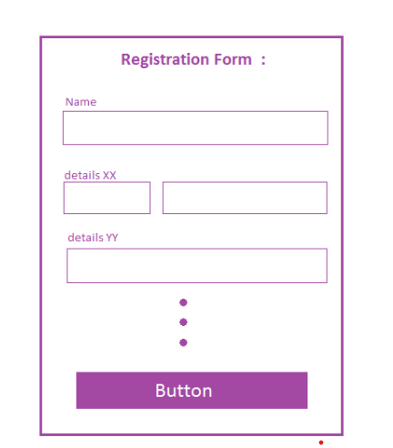

**2.**

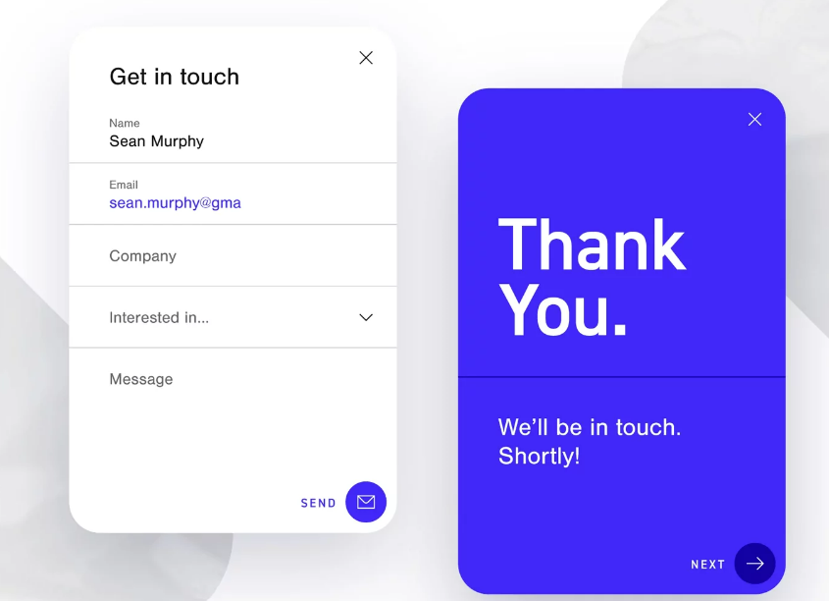

**3.**

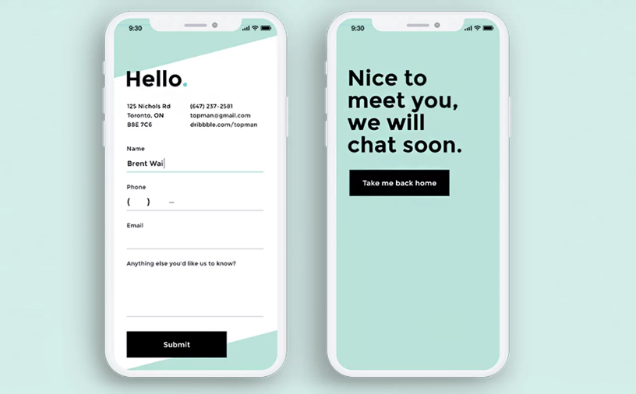

**4.**

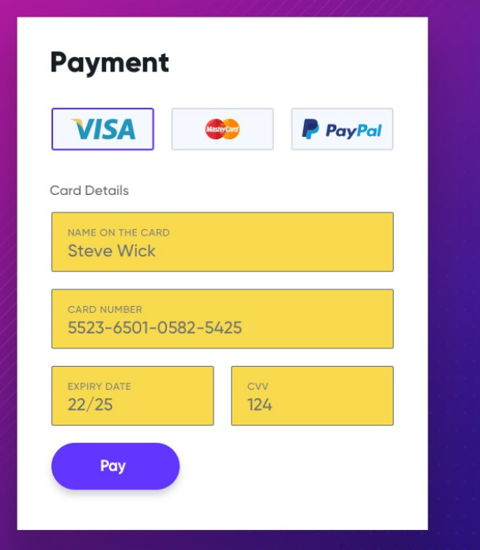

**5. DASHBOARD – JUST DISPLAY INFO**

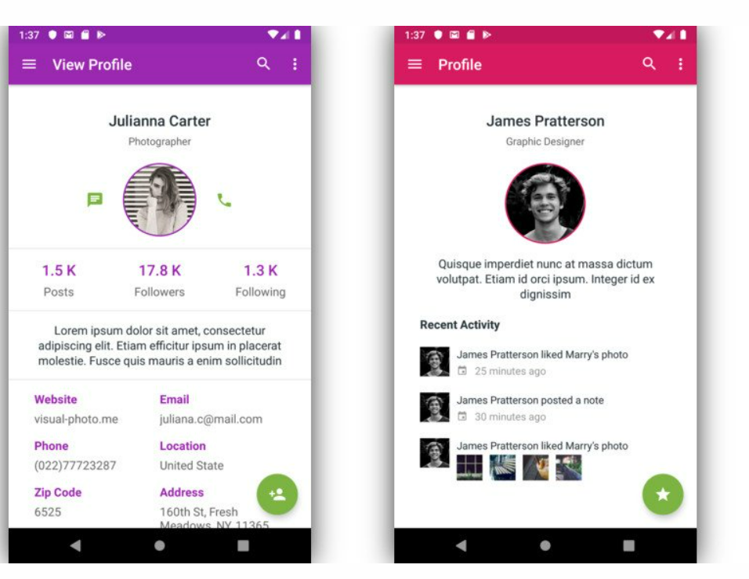

**6.** 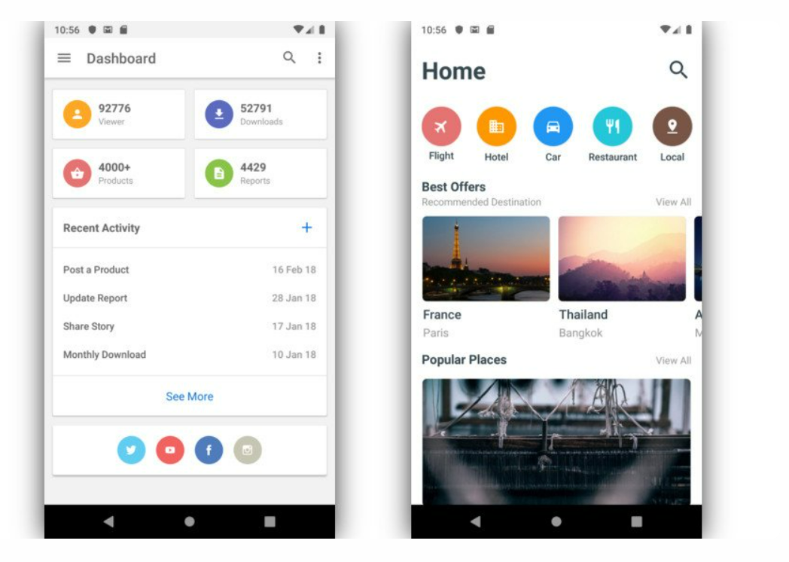

**7.**

